PID Tuning for Steering

I have the box of 4 potentiometer mounted on the tractor electronics board. Two of the potentiometers are connected to pin 37 and 39. The map statements should be adjusted to narrow in on the Kp and Kd settings that are closest to the range needed. This allows for a greater sensitivity using the potentiometers.

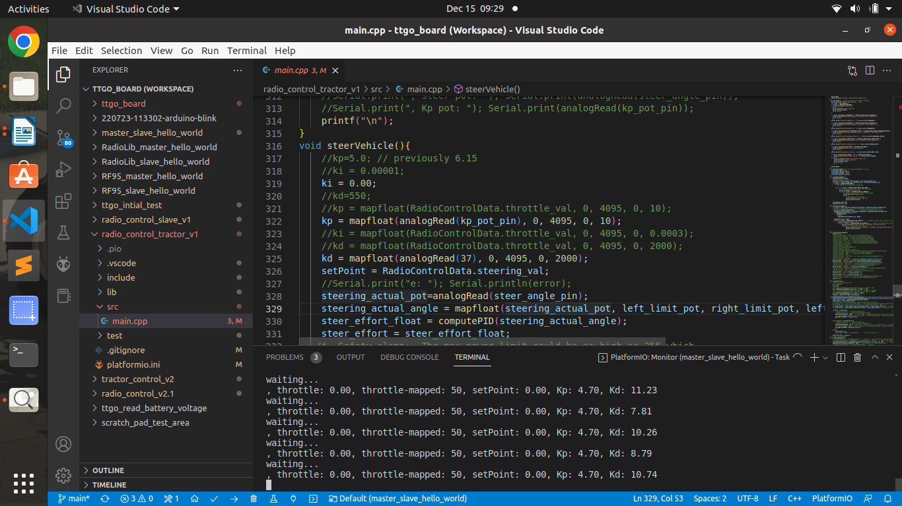
- Disconnect power to the steering motor.
- Connect the laptop. Get the Terminal up to see the Kp, Kd values.
- Make sure the steering potentiometer is straight and the wheels are straight
- Clear all wires and cables away from the steering.
- Start with Kp, Ki and Kd at zero.
- Engage the 12 volt power.
- Move the steering target slightly to the left. Increase the Kp value until the wheels start to move.
- Move the steering target back to straight, then move the steering target more to the right. Adjust the Kp until the wheels reach the target, but don’t overshoot. If the wheels overshoot and start oscillating back and forth then move the steering target to straight and back off the Kp until the back and forth motion stops.
- Increase the steering target slowly until you get to a full left and right without oscillating.
- If you change the line “kp = mapfloat(RadioControlData.throttle_val, 0, 4095, 0, 10);” make sure to first disconnect the power to the steering motor. Then after compile, move the potentiometer to the value that is known good before reconnecting the motor power. For example if before changing the range you know 4.93 is good, then get that value showing before reconnecting power.
- Make note of the Kp value. (12/15/22 -
- Slowly increase Kd until you get results
- Drive the vehicle to capture results using Plotjuggler to visualize the results
- Tweak all three values until you are happy.

Old Notes

Physical connections -
Connected two potentiometers to the TTGO board
  - Pot 1 (Kp) to A1
  - Pot 2 (Kd) to B3

- The code currently gets Kp and Kd from the following:
  - int kp_pot_pin = 39; // analog pin used to connect the transmission servo
  - kp = mapfloat(analogRead(kp_pot_pin), 0, 4095, 0, 10);
  - kd = mapfloat(analogRead(37), 0, 4095, 0, 2000);

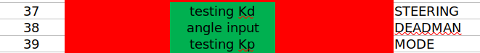

- With left and right limits set, full left is ~9 on dial and full right is ~70 (this is when target_angle = -45 and 45
- Target angle = ~0 @ 40 on the dial – so 39 points left and 30 on the right – not sure what that means really
- Move wheels to straight ahead position
- Lower the wheels
- Move dial left until angle differene is ~5 degrees
- Increase Kp until wheels will move
- When the angle difference <3, Move dial right until angle is 5 degrees the other side
- Currently Kp=2.5, Kd=1.0

